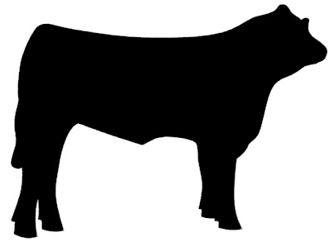
Scholarship Application for Sioux Basin Cattlemen Association
$1000 Scholarship

A. Personal Information

Name:
Current Address
Phone:
E-mail Address:
Date of Birth:

B. Education

Post-secondary institution you will attend next academic year:________________________

Name: Major: ________________________

Honors, Awards, Grants, and Scholarships:
Name of Award | Date | Additional Information

Extra-curricular or other school-related activities (include clubs, positions held):

Academic Plans and Goals:

Special Interests and Skills:

C. Employment

Employment History (please list most recent first):

DATES | EMPLOYER | ADDRESS | POSITION

Do you plan to work during the school year, excluding summer?
Yes: ○ No: ○

Do you plan to work during summer? Yes: ○ No: ○

D. References
(1)Academic
Name:
Position:
Institution/Agency:
Phone/Fax/E-Mail:

(2)Personal

Name:
Address
City, State, Zip:
Phone:

E. Personal Statement (Please attach) (2 part is essay required)

- Write one or two paragraphs explaining the importance of agriculture and how it not only affects you, but everyone else in our world.
- Write one or two paragraphs explaining the importance of associations and organizations, such as South Dakota Cattlemen’s, and how they help you in your agricultural experiences.

Scholarship is due- 4-30

Please submit to: Carl Johnson
46733 246th Street
Dell Rapids, SD 57022

Or by email: Siouxbasincattleman@gmail.com

